Assignment 1b

Dang Khoa Le
Student ID: 103844421
Major: Bachelor of Software Engineering. Tutorial Wednesday, 06.30PM.

Abstract: This document presenting the demonstration for Assignment 1b. The demonstration is based on AWS academy infrastructure.
Objective:
1. Create a secure Virtual Private Cloud (VPC) with subnets, routing tables and security groups.
2. Control access to and from your VPC via an Internet Gateway.
3. Modify the provided PHP code to create a website that stores meta-data information about photos uploaded to S3 in a MySQL database managed by Amazon RDS. The website should enable the user to search for and display photos using meta-data.
4. Deploy and test your PHP web site on an Apache web server running on an EC2 virtual machine instance.
5. Add an additional layer of security by applying a Network ACL to the public subnet that hosts your web server.

I. Creating a VPC:
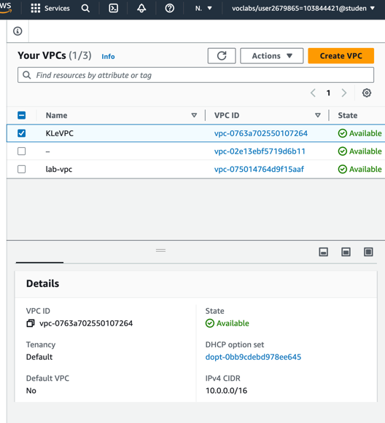
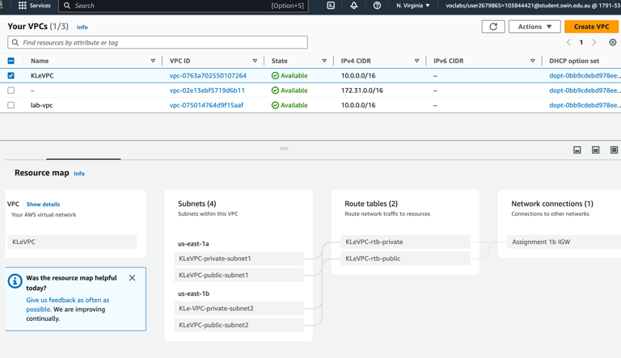
The following images illustrate the configuration of the main VPC for this assignment (named as KLeVPC).
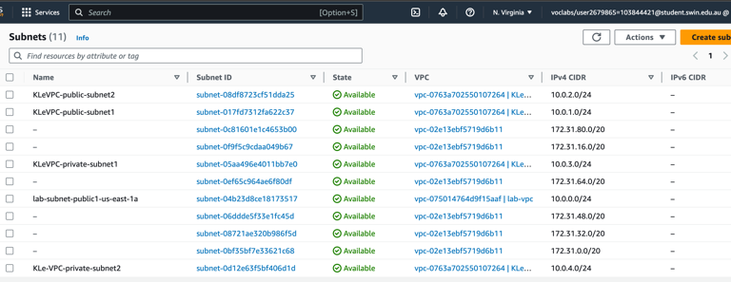
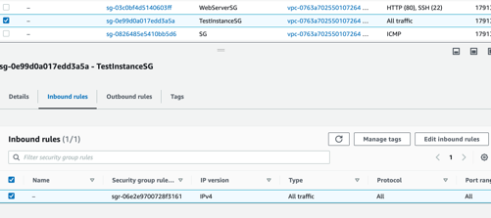
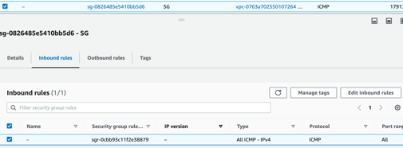
The VPC will be associated by 4 subnets (allocated in 2 subnet groups KLeVPC-rtb-private and KLeVPC-rtb-public). The 4 subnets are KLeVPC-public-subnet1 and KLeVPC-private-subnet1 (us-east1a), KLeVPC-public-subnet2 and KLeVPC-private-subnet2 (us-east1b), which have the IPv4 CIDR of 10.0.1.0/24, 10.0.3.0/24, 10.0.2.0/24, 10.0.4.0/24 respectively.
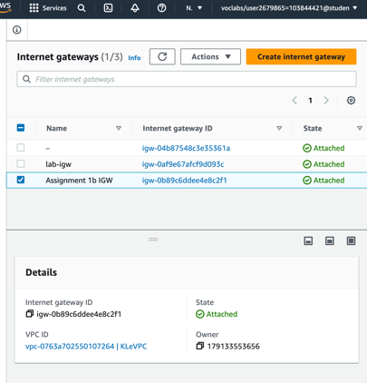
Then, I create an Internet gateway ‘Assignment 1b IGW’ that attached to the main VPC.
Below is the completed Resource map for KLeVPC as indicating their components and how subnets, route tables and network connection (internet gateways) are integrated in this VPC.

II. Creating The Security Groups:
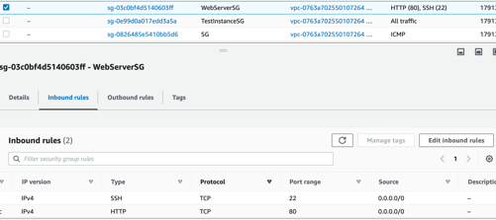
The following images illustrate the configuration of the 4 security groups for this assignment (with KLeVPC).
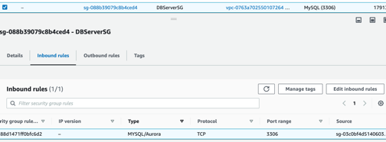
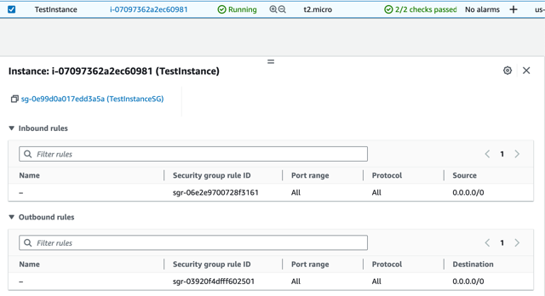
These 4 security groups allow suitable traffics to operate the Web Server as well as allows a proper security interfacing. Security Groups including WebServerSG (for Bastion/WS EC2 instance, allows SSH and HTTP traffics), TestInstacneSG (for TestInstance, allows all traffics), SG (allows ICMP traffics for TestInstance, sourced by TestInstanceSG), and DBServerSG (sourced by WebServerSG, for kle-database, allows MYSQL/Aurora traffics).

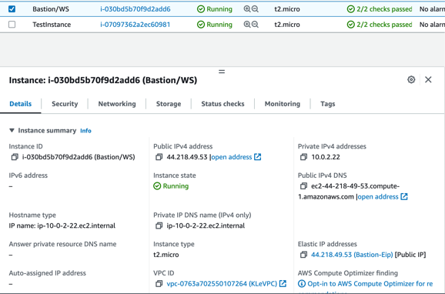
II. Create an EC2 Instance:
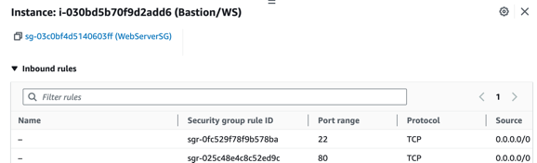
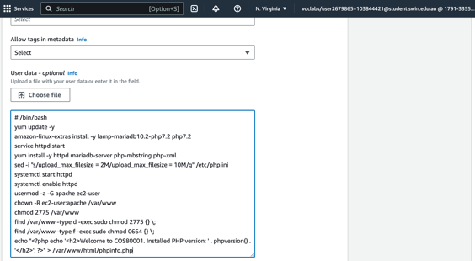
The following images illustrate the configuration for the 2 main EC2 instances and their associations.
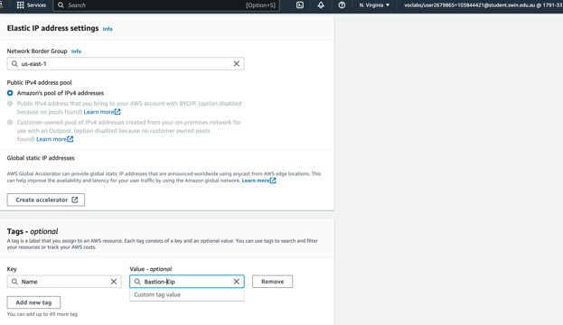
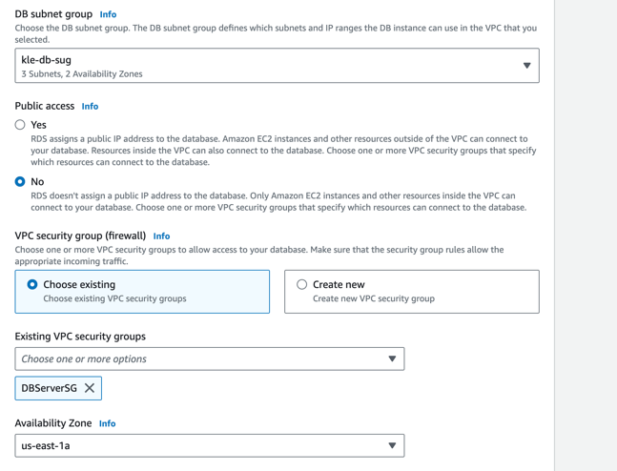
The Bastion/WS (Web Server) instance is allocated in KLeVPC’s public subnet 2 (KLeVPC-public-subnet2), associated with the WebServerSG security groups and the Bastion-Eip Elastic IP address (providing the fixed public IPv4 DNS for the instance). I also update the user data with the Apache http server and php, installed from the resource of Assignment 1b.
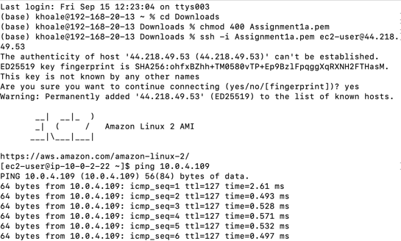
The TestInstance is used to test the Web Server instance and it is allocated in KLeVPC-private-subnet2, associated with the WebServerSG security groups.
Above are the detailed command and output lines when I ping (ICMP) the TestInstance from Bastion/WS. This is done by accessing the private Test instance from the public Bastion/Web Server instance with Pageant agent forwarding.

III. Creating The RDS Database:
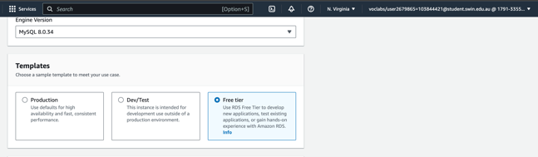
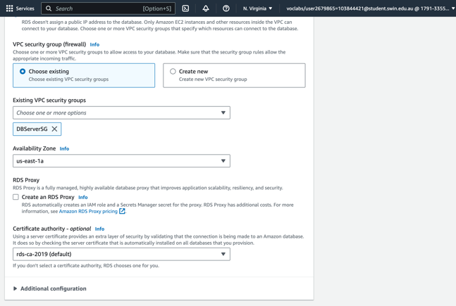
The following images illustrate the configuration for the RDS database and its associations.
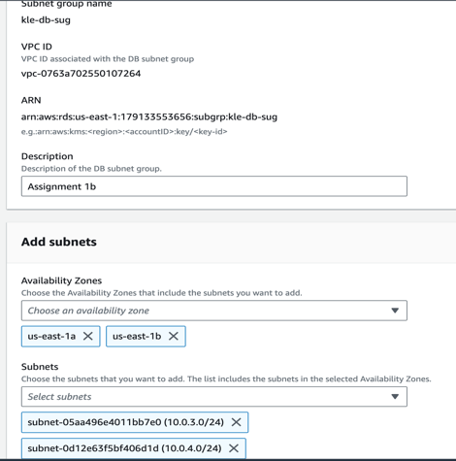
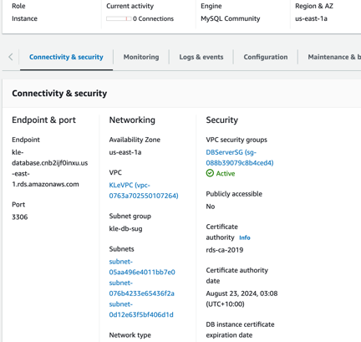
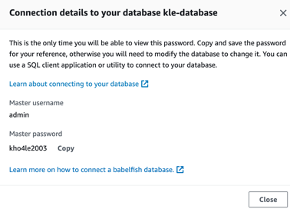
The RDS database is named as kle-database, below is its detailed connectivity and endpoint. The database is associated with the KLeVPC, KLeVPC-private-subnet1 and use the DBServerSG security group.
In advanced to this RDS database, I also have created a subnet group (kle-db-sug) of 2 private subnet (KLeVPC-private-subnet1 and KLeVPC-private-subnet2), this subnet group also use 2 availability zones us-east-1a and us-east-1b, thus it is compatible with the Web Server.

IV. Create Network ACL:
The following images illustrate the configuration for the Network ACL (KLe-ACL) and its inbound rules (Allow SSH and ICMP traffics).
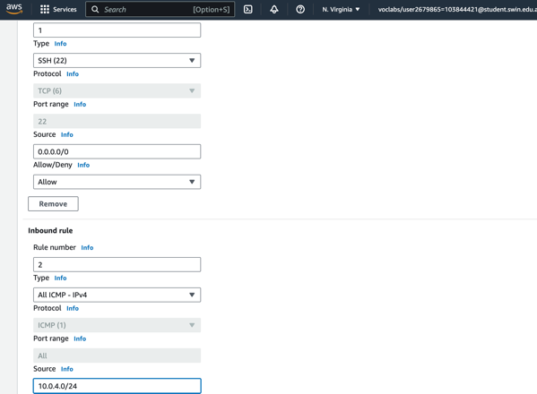
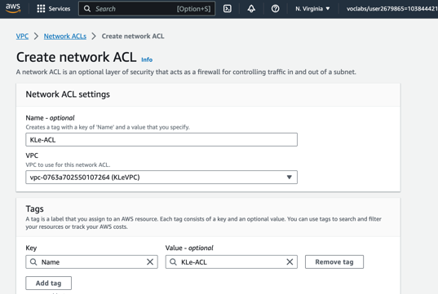
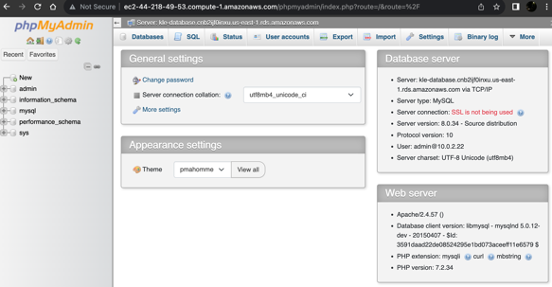

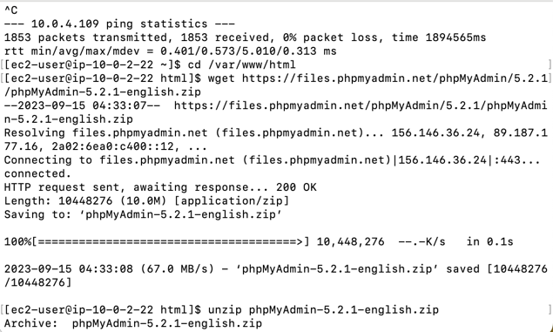
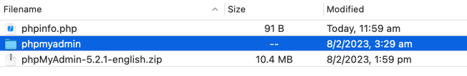
V. Installing phpMyAdmin:
The following images illustrate how I installed phpMyAdmin to Bastion/Web Server.
From the command line of my local terminal, I have to download the phpmyadmin file, then unzip and move them appropriately to the specified directory. Then, logging to my EC2 instance by using the SFTP method and my key pair (pre-named as Assignment1a) on Cyberduck, then moving to the var/www/html/phpmyadmin, locating the file config.sample.inc.php and change the name to, config.inc.php. After that, open the file and edit the line by using my RDS endpoint (on Visual Studio Code):
$cfg['Servers'][$i]['host'] = 'localhost';
Into:
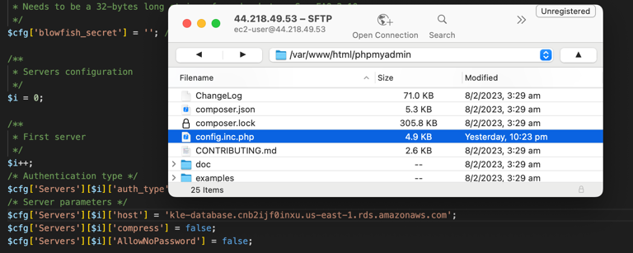
$cfg['Servers'][$i]['host'] = ‘kle-database.cnb2ijf0inxu.us-east-1.rds.amazonaws.com’;
Then I am able to enter the username and password of my DB to login to phpMyAdmin, running on my Web Server instance, by using my Bastion/WS instance Public DNS:
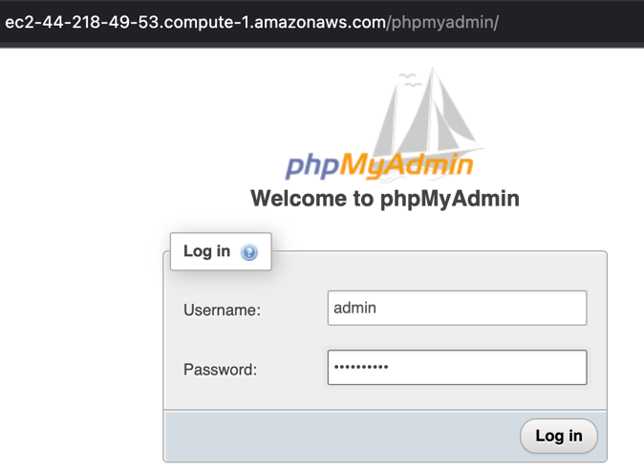
http://ec2-44-218-49-53.compute-1.amazonaws.com/phpmyadmin/

VI. Creating S3 Bucket:
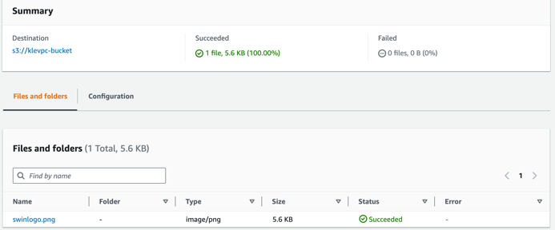

The following images illustrate the configuration for the S3 Bucket named ‘klevpc-bucket’.
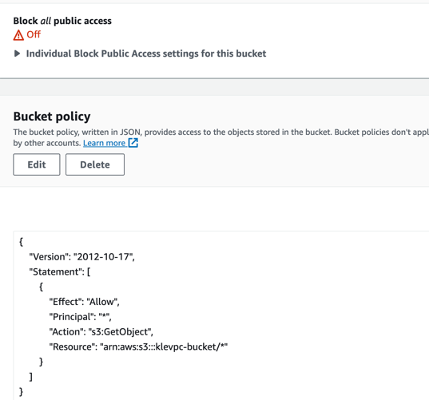
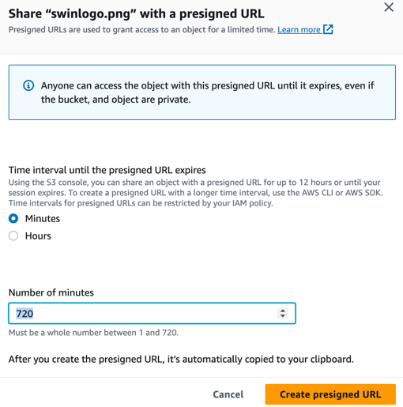
A Swinburne logo is uploaded onto the bucket as above while the bucket’s access policy also has been modified to be publicly accessible.
The Swinburne logo object, also has enabled to be shared with presigned URL:
https://klevpc-bucket.s3.amazonaws.com/swinlogo.png

VII. Modifying phpMyAdmin Page:
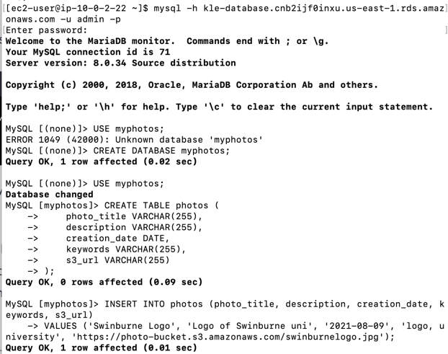
The following images illustrate the modification for the http web-page phpMyAdmin.
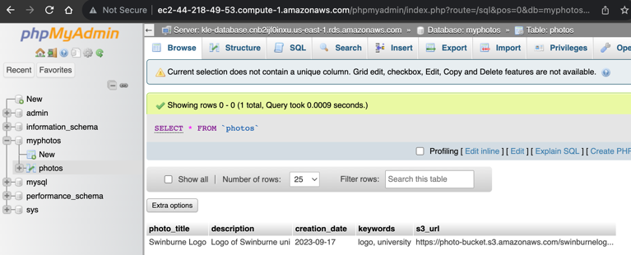
Above is my creation of the record to populate the database table, using my local machine command tool (terminal).
Above is my photos table (with the records) of the Swinburne logo previously uploaded to S3 bucket.

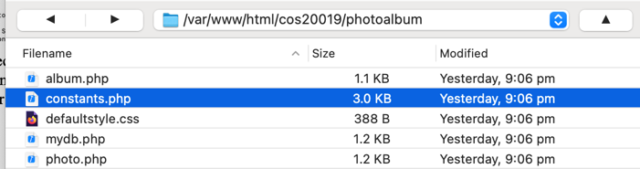
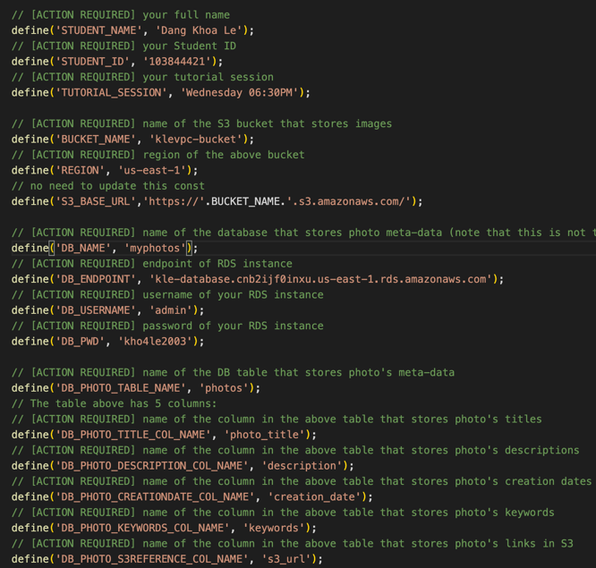
Below are my modification for the file php.constants (edited by Visual Studio Code) and the new table storing my new images named as myphotos.
Below is my creation and configuration of the new table myphotos storing the 4 new photos presenting my life.
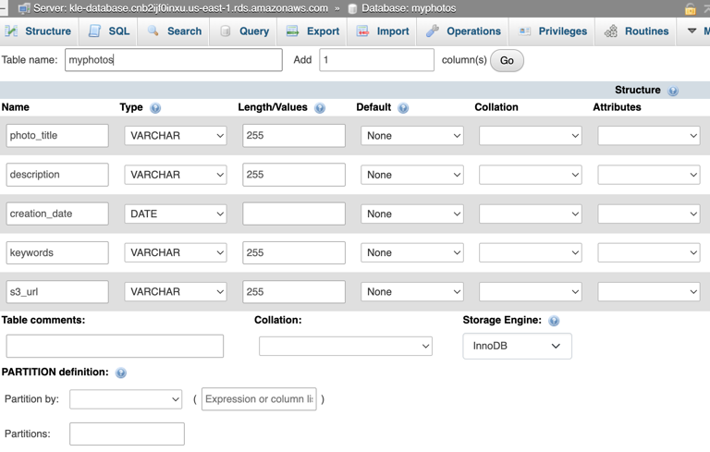
Below is how I record the details of the 4 new photos alongside with the Swinburne logo by using SQL on phpMyAdmin.
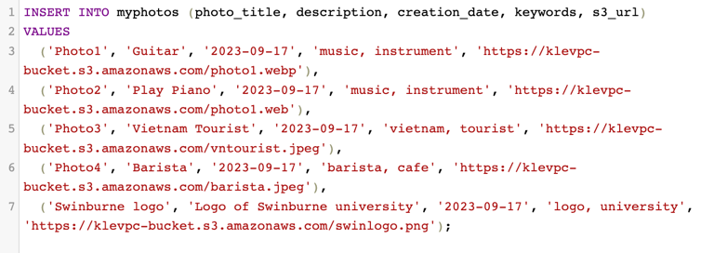
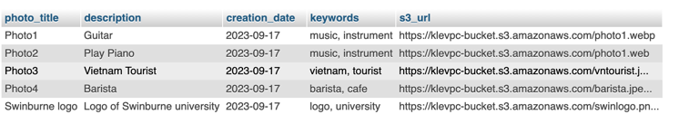

VIII. Accessing The Photo:
Apparently, I can access all of my uploaded photos by the following http link:
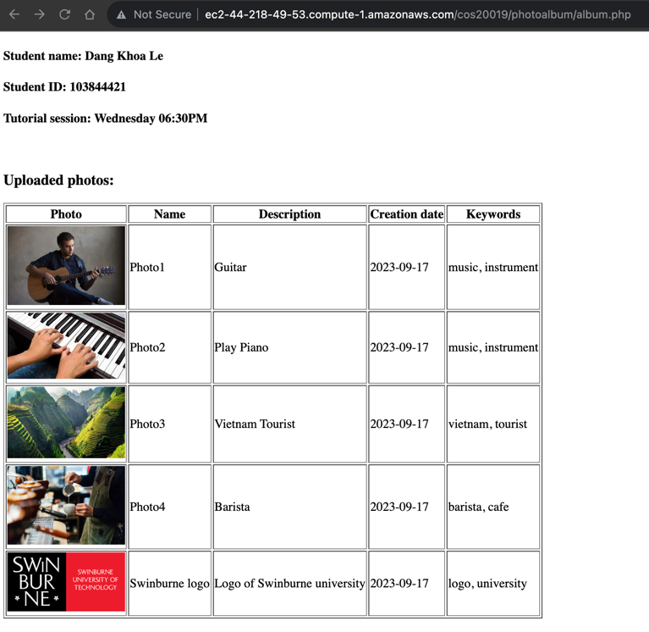
http://ec2-44-218-49-53.compute-1.amazonaws.com/cos20019/photoalbum/album.php
(Various figures in this project may simultaneously demonstrate irrelevant topic as they are used as testing, please ignore).

